1. Create s3 bucket and upload some objects to s3.

**Goto Amazon S3 and Buckets --🡪 click on create bucket**

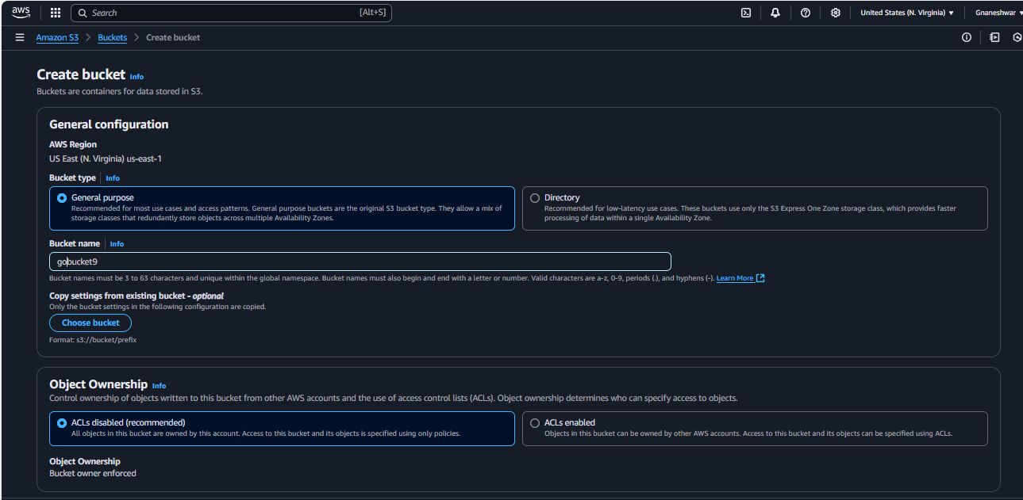

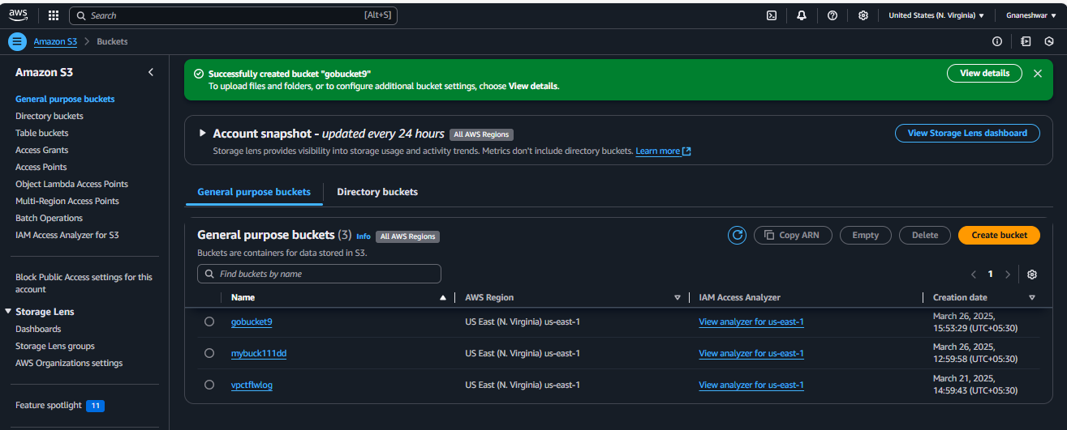

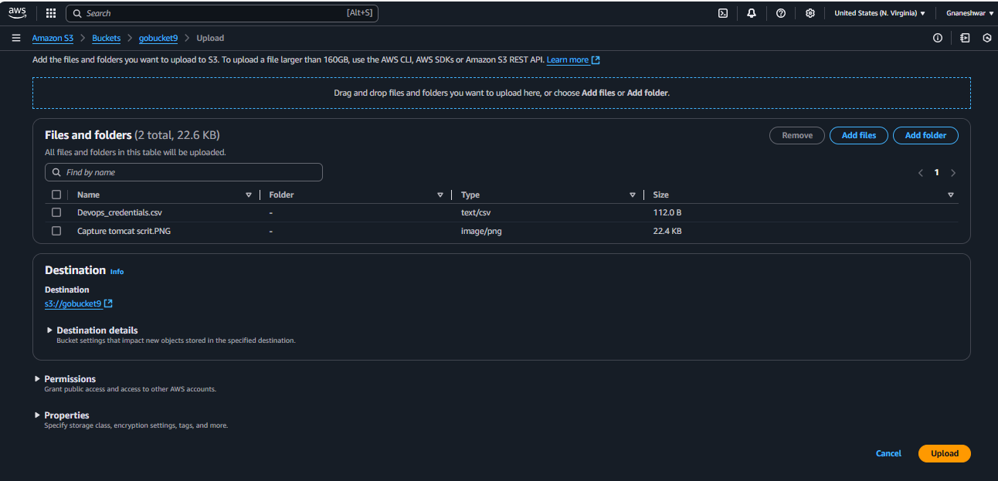

1. Deploy static website in s3 bucket.

**Enable Static web hosting option**

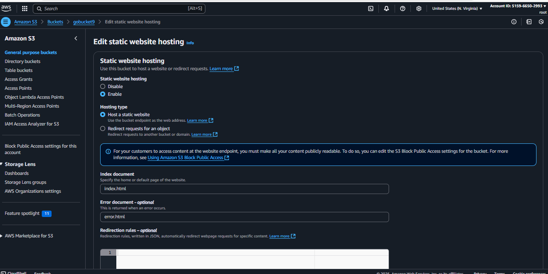

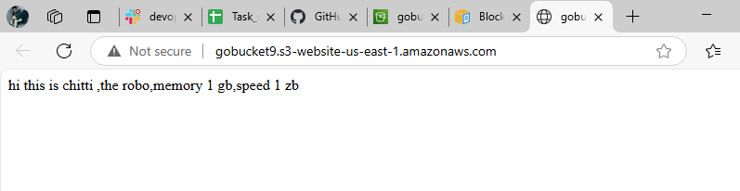

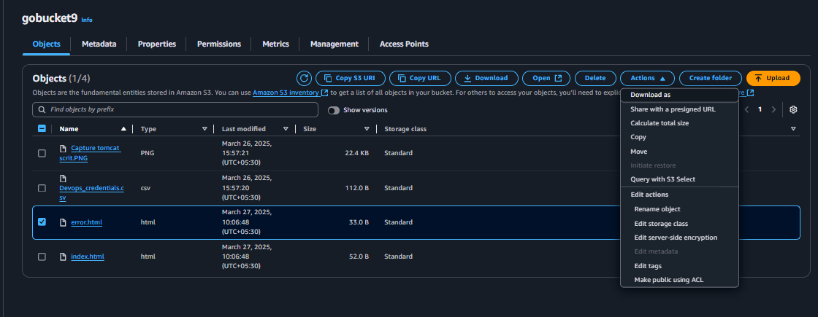



1. Enable cross region replication on s3 buckets.

**Create 2 buckets in 2 different regions with enabling the Object versions**

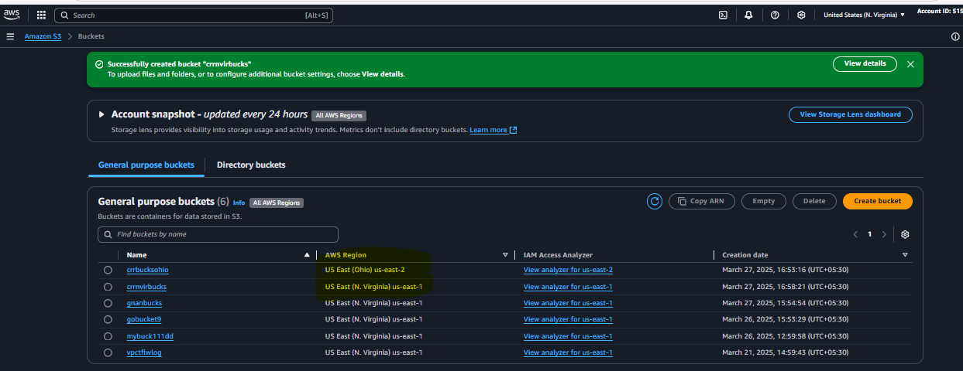 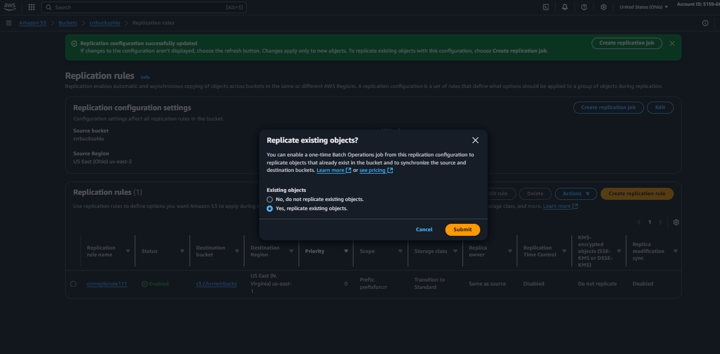

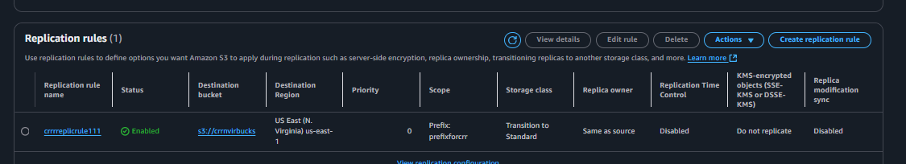

4) Configure bucket policy,only Admin user can see the objects of s3 bucket.

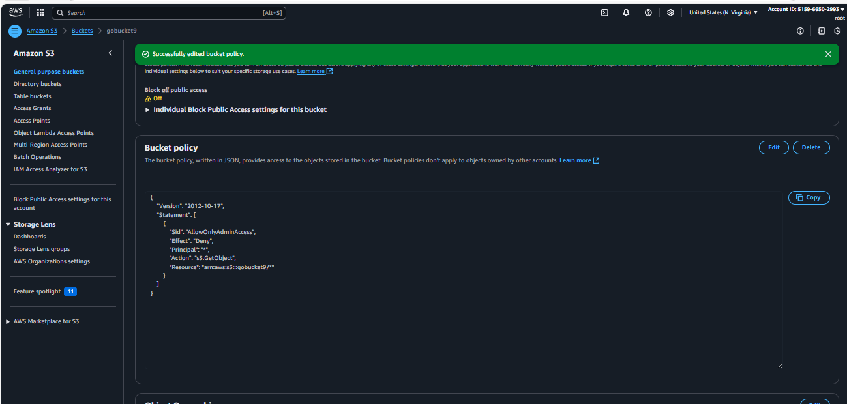

5) Setup lifecycle policies to automatically transition or delete objects based on specific criteria.

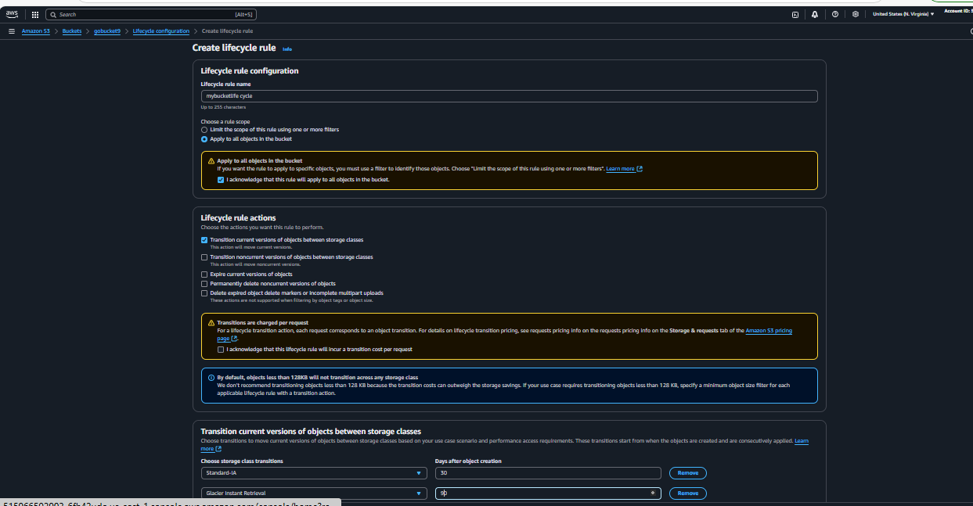 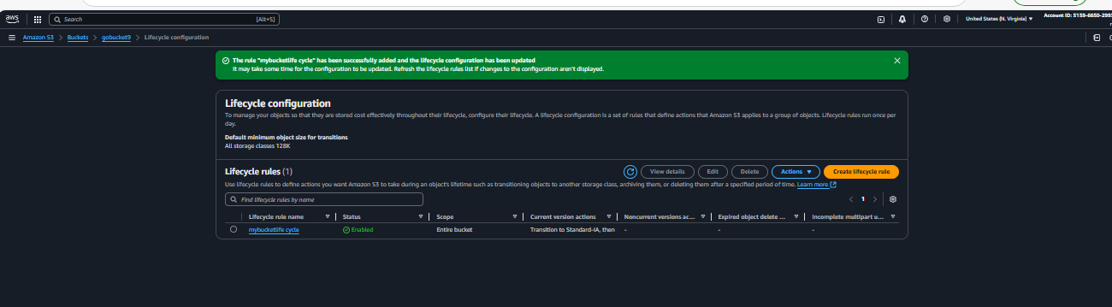

6) Push some objects in s3 using AWS CLI.

Goto Gitbash and connect using ssh and configure aws by using command aws configure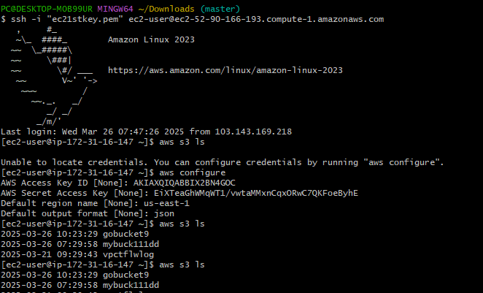

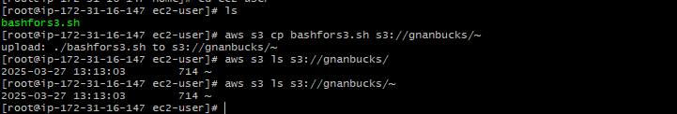

7) Write a bash script to create s3 bucket.



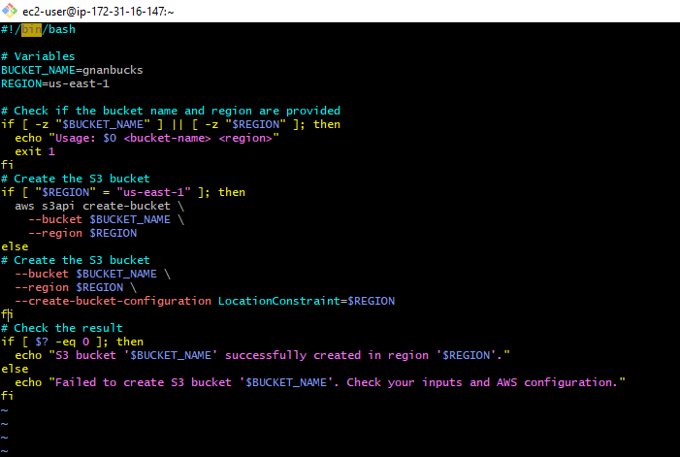 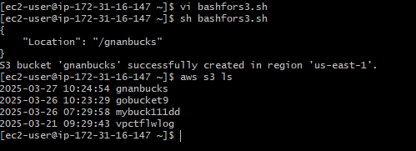

8) Upload one 1 gb of file to s3 using cli.

**AWS CLI automatically manages multipart uploads for files larger than 5 GB. For your 1 GB file, it will use a standard upload, but you can optionally specify a transfer acceleration for improved speed**

